**HISTORY**

**DEPARTMENT PROFILE**

• About Department

• Objectives

• Results

• Events

• Faculty Profile

**About Department**

**Our Department started in the year 1979. In the beginning students strength was satisfied, but year by year it was increased. we are very happy because our strength was in the way of progress. History was introduced as one of the major subjects. As per the direction of Karnataka University Dharwad, three Subjects of equal importance came in to existence. From 2005-06 on words semester system was introduced and our college affiliated by Karnataka State Akkamahadevi womens university Vijayapura. Presently our department has one qualified Staff Sree.Chandrashekhar M.K is the present Head of the Department**

**Objectives of the Department**

**The term History has been derived from the Greek words “Historia” the word history means enquiry or research. Broadly speaking, the systematic study of the life of mankind is delt in history. The study of History gives as on account of the evolution of the culture of mankind since ancient times. History presents an ocean of experiences of different people. It retraces the transition of mans life from barbarism to civilization. The study of history has been useful to man in many ways.**

**The main objectives of teaching History may be as follows:**

* **To promote an understanding of the processes of change and development through which human societies have evolved to their present stage of development.**
* **To promote an understanding of the common roots of human civilization and an appreciation of the basic unit of mankind.**
* **To develop an appreciation of the contribution made by various cultures to the total heritage of mankind.**
* **To foster the understanding that the mutual interaction of various cultures has been an important factor in the progress of mankind.**
* **To facilitate the study of the History of specific countries in relation to and as parts of the general History of mankind.**

**Results**

All Stream Results 2016-2020

| **Year** | **Appeared** | **Passed** | **Passing %** |
| --- | --- | --- | --- |
| **2015-16** |  |  | **%** |
| **2016-17** |  |  | **%** |
| **2017-18** |  |  | **%** |
| **2018-19** |  |  | **%** |
| **2019-20** |  |  |  |

**Events**

EVENTS ORGANISED 2017-2021

| Sl.No | Date | Name of the Activity | Title of the Activity |
| --- | --- | --- | --- |
| 01 | 2017-18 | Guest Lecture | Sources: Ancient Indian History |
| 02 | 2018-19 | Extension | Temple Architecture |
| 03 | 2018-19 | Study Tour | Harihara Temple |
| 04 | 2019-20 | Guest Lecture | Temple Architecture |
| 05 | 2019-20 | Quiz | Indian History |
| 06 | 2020-21 | Quiz | Indian History |

**CURRICULUM VITAE**

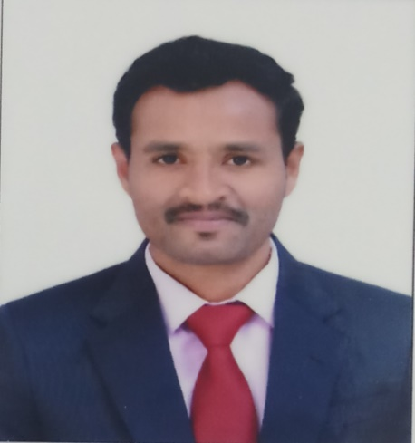

|  |  |
| --- | --- |
| **Name** | Mr.CHANDRASHEKHARA. M K |
| **Qualification** | M.A.(Ancient Indian History and Europe); M.Ed.; KSET;( Ph.D) |
| **Domain Specialization** | Art History and Historiography |
| **Date of Appointment** | 10th August, 2016 –Assistant professor at BAJSS Arts and commerce college for women Ranebennuru |
| **Present Designation** | Assistant Professor |
| **Mandatory In-service Courses** | * **Orientation Course :** * **Refresher Course-I : UGC-Human Resource Development Centre University of Hyderabad. 4th August 2020 to 18th August 2020 and obtained grade “B”** * **One week National level online multi-disciplinary FDP  on Impact of covid-19 on Higher education and Society. Held from  27th  May To  02nd  June 2020.** * **Annamalai University  7 day National level faculty development program(FDP) for teaching staff on research methodology in temple studies.** * **International web seminar on Role of Museums Today  in Conserving and Showcasing Rural, Folk-Art art and Culture.  Jointly organised by government Central Museum, department of of archaeology and museum Jaipur, Rajasthan.** * **Under Paramash scheme sponsored by UGC,**   **one week National level faculty development program(FDP) on “Transformation in  Indian education through new education policy challenges and opportunities”  Government first grade college for women Balmatta  Mangalore in Association with ST Aloysius College (Autonomous) Mangalore**   * **UGC- PARAMARSH funded National Webinar on “Unceasing war against pestilence: past and present of pandemics” MAR ATHANASIUS COLLEGE (Autonomous ) Kothamangalam Kerala** |

**Organization of Seminars/ webinars**

|  |  |  |
| --- | --- | --- |
| **Seminar** | **Organisational Responsibility** | **Participant** |
| **One day a National Level Webinar On Art and  Architecture of  Mughals empire**  **BAJSS Arts and commerce college for women Ranebennuru** | **Organising Secretary** | **120** |

**Research Articles in International Journals**

|  |  |  |  |
| --- | --- | --- | --- |
| **Journal** | **Publisher** | **Article** | **Mode** |
| IJCRT  Vol IX Issue 8 ,August 2021 | International Journal of Creative Research Thoughts | Backward class movement in Karnataka and its imapacts | ISSN-23202882 |
|  |  |  |  |